Sulz am Neckar, November 2021

Pneumatic clamping elements from KIPP: Efficient processes automation

HEINRICH KIPP WERK has added diverse types of pneumatic clamping elements to its range. The products enable the easy clamping and centring of several elements using compressed air, thus reducing setup times.

The new components are designed for simple clamping and positioning tasks and prove their worth wherever workpieces need to be quickly and automatically exchanged: e.g. when changing pallets, fixture plates or robotic accessories. They also enable simultaneous (un)clamping of attachments and, with centring clamps, permit direct positioning and clamping of components without using a mating part.

Pneumatic clamping elements from KIPP impress through their compact design and the rust-free version with stainless steel bodies. Pins and bushes are hardened to prevent wear during frequent operating cycles. Seals made of the elastomer NBR also contribute to this. So equipped, KIPP clamping elements are also and especially suitable for demanding operating conditions in semiconductor manufacturing, food processing and pharmaceutical and cosmetic production environments. This is also where the good repeat accuracy of ca. ± 0.2 mm scores points. The operating pressure is 0.3-0.7 MPa.

Two different positioning adapters (single or double-acting) for clamping with pins are available. They provide a clamping force of 30 or 40 N (at 0.5 MPa). The flanged version has a safety function – an integrated spring engages if the compressed air pressure drops. Clamping via locating bushes is possible with positioning cylinders. The two available variants differ in the clamping principle: In variant 1 a spring performs the actual clamping operation. The clamping force here is 50 N. Compressed air is used to release the clamp. Variant 2 is not initially in the clamping state. With compressed air, the positioning cylinder achieves a clamping force of 150 N (at 0.5 MPa). The range is rounded off by centring clamps for direct workpiece clamping. They permit clamping diameters of 16-20 mm and a retaining force of 77 N (at 0.5 MPa).

(Characters including spaces: 2,108)

Image overview:
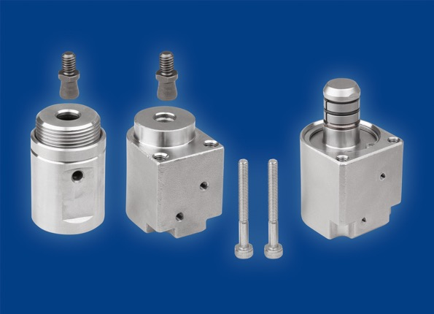
KIPP offers two different pneumatic positioning adapters (cylindrical or flanged) for clamping with pins as well as a centring clamp.
Image: KIPP

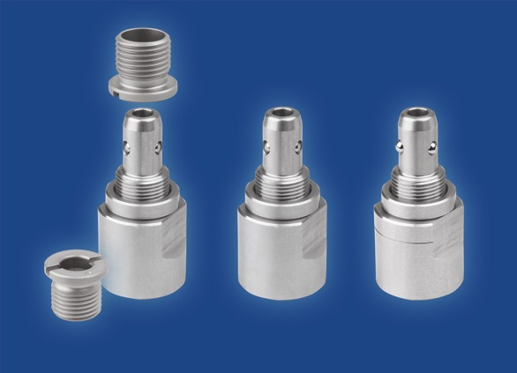
The pneumatic positioning cylinders from KIPP are suitable for clamping via locating bushes; they have a clamping force of 150 or 50 N (at 0.5 MPa).
Image: KIPP

HEINRICH KIPP WERK GmbH & Co. KG
Stefanie Beck, Marketing
Heubergstrasse 2
72172 Sulz am Neckar

Telephone: +49 7454 793-30
Email: stefanie.beck@kipp.com

