Sulz am Neckar, March 2022

New 5-axis vice KIPPflexX 90 mm

HEINRICH KIPP WERK has expanded the KIPPflexX series to include a 90 mm wide compact vice that is designed for 5-axis milling machines with smaller tables. This new product now enables workpieces sized around 100 mm to be machined with completely free access to the outer contours.

As with the larger KIPPflexX 125 mm, the KIPPflexX 90 mm can be used as a centric vice with draw-down function or as a standard vice for clamping rough parts (2IN1). The operating principle and the clamping forces of the two products are identical. The support height of the KIPPflexX 90 mm is 155 mm. Due to the smaller size, users benefit from space saved. If larger workpieces need to be clamped, two vices can be mounted side by side.

This 5-axis vice provides a versatile solution for any 5-axis milling machine. A special feature is the user-friendly rapid adjustment using a crank handle. The flat guide ensures greater stability and rigidity in the clamping system, which provides an exceptionally high clamping force of 52 kN. A large selection of different jaw plates are available including smooth, with pins, combi-stepped or with machining allowance.

KIPPflexX is suitable for mounting on machine tables with T-slots or tapped holes. Central alignment is achieved by means of the middle hole. The baseplate has longitudinal and transverse alignment slots. However, the 5-axis vice can also be mounted on any grid element or directly onto zero-point clamping systems. The clamping physics with intelligent force distribution ensure that only low torques are transmitted to the machine table.

(Characters including spaces: 1,615)

Image overview:
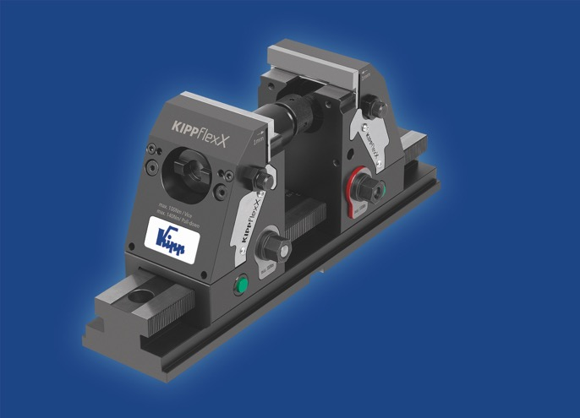
HEINRICH KIPP WERK has expanded the KIPPflexX series to include a 90 mm wide vice.
Image: HEINRICH KIPP WERK

HEINRICH KIPP WERK GmbH & Co. KG
Stefanie Beck, Marketing
Heubergstrasse 2
72172 Sulz am Neckar, Germany

Telephone: +49 7454 793-30
Email: stefanie.beck@kipp.com

